Joshua Davidov
Professor Wright
ME436A-IS
April 15th, 2026
Paschen Curve Graphing Assignment
In this assignment, we:
a) Plot the Paschen curves for air, argon, and carbon dioxide.
b) Plot points representing the the breakdown voltage of air at different selected values.
c) Derive
All relevant Paschen Law constants ( and ) to plot the Paschen curves of relevant gases were derived from Table 1 of “Suppression of electrical breakdown phenomena in liquid TriMethyl Bismuth based ionization detectors"¹.
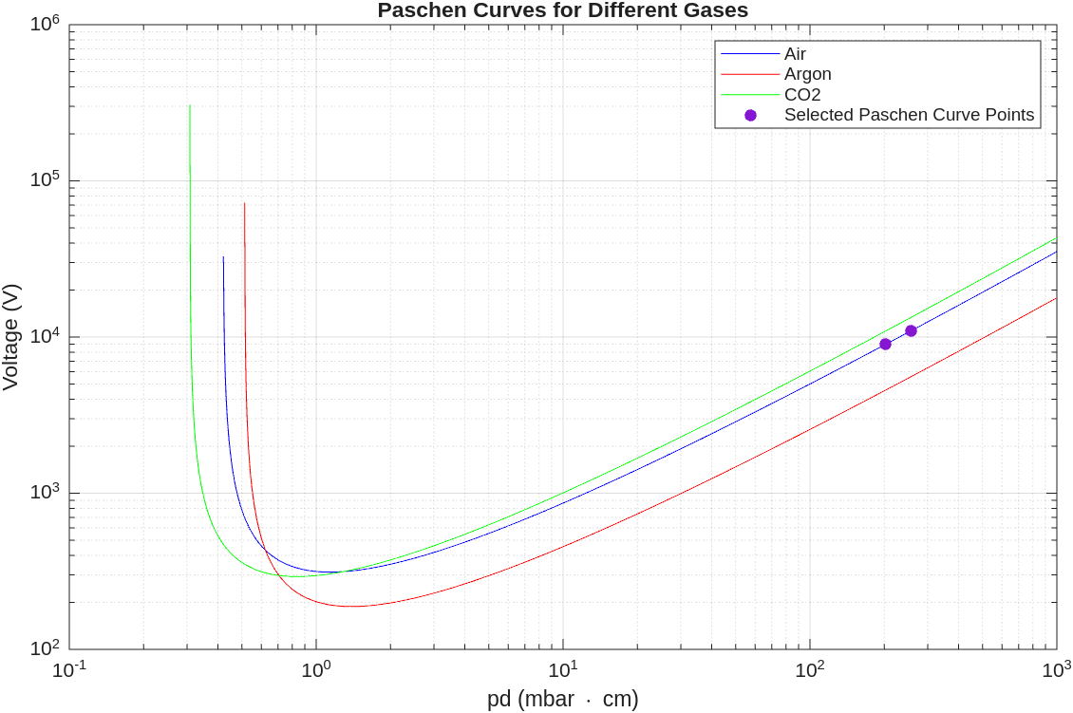
We claim:
Recall the equation for the Paschen’s Law:
(1)
To find take the derivative of in respect to :

(2)
Recall that has a local extrema at if:

Note that .
Therefore, we can compute the zero(es) of the derivative of in respect to by calculating the zeroes of . Let:

(3)
Therefore, is a local extrema of .
We also claim that , which we can prove rigorously by analyzing the second derivative of in respect to .
INSERT SECOND DERIVATIVE ANALYSIS HERE
Now, compute at that local extrema:

(4)

Appendix MATLAB Code
Here was the following code to generate the MATLAB figure:
%% Params. for Paschen Curve

pd = logspace(-1,3,2000); % 0.1 to 1000 on a log-spaced grid
gamma = 0.01; %dimensionless; assuming electrodes are made out of stainless steel
Patm = 1013.25 %mbar
x = [Patm*0.2, (Patm+(4*68.948))*0.2] %mbar*cm

% Air
A_Air = 11; %m*bar^(-1)*cm^(-1)
B_Air = 274; %V*bar^(-1)*cm^(-1)
% Calculate the Paschen curve for Air
V_Air = B_Air .* pd ./ (log(pd) + log(A_Air) - log(log((1 / gamma) + 1)));
V_Air((log(pd) + log(A_Air) - log(log((1 / gamma) + 1))) <= 0) = NaN;

% Ar
A_Ar = 9; %m*bar^(-1)*cm^(-1)
B_Ar = 135; %V*bar^(-1)*cm^(-1)
V_Ar = B_Ar .* pd ./ (log(pd) + log(A_Ar) - log(log((1 / gamma) + 1)));
V_Ar((log(pd) + log(A_Ar) - log(log((1 / gamma) + 1))) <= 0) = NaN;

% CO2
A_CO2 = 15 %m*bar^(-1)*cm^(-1)
B_CO2 = 350 %V*bar^(-1)*cm^(-1)
V_CO2 = B_CO2 .* pd ./ (log(pd) + log(A_CO2) - log(log((1 / gamma) + 1)));
V_CO2((log(pd) + log(A_CO2) - log(log((1 / gamma) + 1))) <= 0) = NaN;

% Plot the Paschen curves for Air, Argon, and CO2
figure;
loglog(pd, V_Air, 'b', 'DisplayName', 'Air');
hold on;
loglog(pd, V_Ar, 'r', 'DisplayName', 'Argon');
loglog(pd, V_CO2, 'g', 'DisplayName', 'CO2');
y_air_pts = interp1(pd, V_Air, x, 'makima');
scatter(x, y_air_pts, 'filled', 'DisplayName', 'Selected Paschen Curve Points');
hold off;
grid on;
xlabel('pd (mbar \cdot cm)');
ylabel('Voltage (V)');
title('Paschen Curves for Different Gases');
legend('show');

References
[1] B. Gerke et al., “Suppression of electrical breakdown phenomena in liquid TriMethyl Bismuth based ionization detectors,” Journal of Instrumentation, vol. 17, no. 09, p. P09029, Sep. 2022, doi: 10.1088/1748-0221/17/09/P09029.

